www.qaprogrammer.com

Performance Test report

# **Test Details**

* **Test Date:** 11/10/2019
* **Load:** 5000 Users
* **Duration:** 30 Mins
* **Environment:** qa.purchasingpower.travel

# **Observations & Recommendations**

* All Failures are due to 503 Errors & Failed to Respond by server
* Application started throwing errors from ~100 Users.
* **Random View Of Hotels –** Has less number of transactions compared to **Search** due to most of the Searches did not returned any results and thrown errors.
* **Random View of Hotels** also failed with a higher percentage due to Service Unavailable & Timeout
* Observed Errors gradually started from 1500 Concurrent Users, spiked to high at 3000 Users, continued till end of the test.

# **Response Time Summary**

|  |  |  |  |  |  |  |  |  |  |
| --- | --- | --- | --- | --- | --- | --- | --- | --- | --- |
|  |  | **Response Time in Seconds** | | | | | | |  |
| **Transaction/Page** | **# Samples** | **Average** | **Median** | **90% Line** | **95% Line** | **99% Line** | **Min** | **Max** | **Error %** |
| 01-OpenURL | 44898 | 76.613 | 66.54 | 154.346 | 173.408 | 196.446 | 0 | 218.093 | 24.21% |
| 02-Enter NewYork City | 30297 | 48.676 | 47.764 | 90.796 | 100.357 | 111.822 | 0.907 | 119.869 | 18.83% |
| 03-Search | 24067 | 95.951 | 96.342 | 154.594 | 166.825 | 193.718 | 0 | 222.658 | 64.89% |
| 04-RandomView_Hotel | 1964 | 109.34 | 103.956 | 193.086 | 209.168 | 233.513 | 0 | 267.299 | 45.83% |

# Concurrent Users:

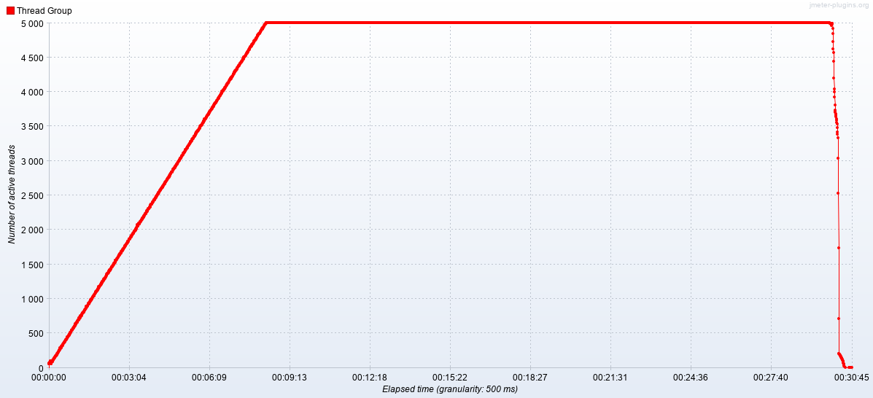

# Response time over time

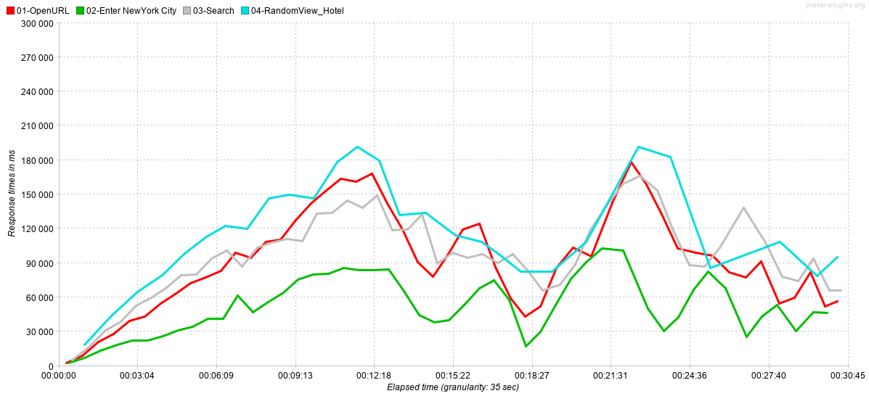

# Random Snap shots of Error

